SIMATS ENGINEERING
ASSESSMENT TOOL 3

COURSE NAME: Artificial Intelligence COURSE CODE: CSA17

COURSE OUTCOME COVERED
CO5: Design AI-based systems using PySpark, RDD operations, and intelligent agent architectures, using scalable systems and integrate components in distributed AI applications. (BTL 5)
Assessment Tool Weightage: 20%

QUESTIONS: 5
Duration : 1 Hour
Total Marks:50
Annexure A

Reverse Engineering

Code of Conduct:
I S.Chandra shekar (192372163)(Name / Reg No) certify that this submission is my original work and that I have adhered to the guidelines specified for this assessment.
I understand that any violation of academic integrity rules will result in disciplinary action.
Signature of the student:S.Chandra shekar

Annexure A

Reverse Engineering

1. System Decomposition & Analysis
Analyze an existing AI-based system and reverse engineer its architecture, identifying key components, data flow, and underlying algorithms.
2. Architecture Reconstruction
Given a black-box software system, reconstruct its system architecture and explain the interaction between modules using appropriate diagrams.
3. Algorithm Identification
Reverse engineer a machine learning application to identify the algorithms, data processing steps, and decision-making logic used in the system.
4. Data Flow & Process Mapping
Examine an existing distributed AI application and map its data flow, processing pipeline, and communication between components.
5. Improvement & Redesign
Perform reverse engineering on an intelligent system and propose enhancements or redesign strategies to improve scalability, efficiency, and performance.

ANSWERS

System selected for reverse engineering: a distributed, PySpark-based Movie/Content Recommendation Platform (comparable in structure to systems used by Netflix / Amazon Prime), built on RDD-driven collaborative filtering with an intelligent multi-agent personalization layer. The five questions below reverse engineer this system end-to-end.

Question 1: System Decomposition & Analysis
Overview
The black-box system accepts streaming user-interaction events (clicks, watch time, ratings) and returns personalized content recommendations in real time. Treating it as a black box and observing its inputs/outputs, logs, and API responses, the system can be decomposed into the following layers, each independently deployable and scalable.
Key Components Identified
- Ingestion Layer – Data ingestion collects raw events from the client apps and pushes them onto a Kafka topic for durable, ordered delivery.
- Storage Layer – HDFS/S3 store raw and processed data; a feature store holds engineered vectors for fast lookup during inference.
- Distributed Processing Layer – A Spark cluster (Driver + Executors) performs distributed RDD transformations — map, filter, reduceByKey, join — to clean, join, and aggregate user–item interaction data.
- Model / Algorithm Layer – Alternating Least Squares (ALS) for collaborative filtering and K-Means for user segmentation are trained on RDDs and persisted to a model registry.
- Intelligent Agent Layer – Independent agents (Recommendation Agent, Personalization Agent, Monitoring Agent) consume model outputs, apply business rules, and negotiate the final ranked list shown to the user.
- Interface Layer – A REST API gateway authenticates requests and routes them between the client, the agent layer, and the model-serving layer.
Data Flow (summary)
Raw events → Kafka → Spark Streaming micro-batches → RDD transformations (ETL + feature extraction) → ALS/K-Means training or inference → agent decision logic → ranked recommendations returned via the API gateway → user feedback captured and re-ingested, closing the loop.
Underlying Algorithms Inferred
From response latency patterns, the size of the item-embedding vectors in API payloads, and cold-start behaviour observed for new users, the system is consistent with matrix-factorization-based collaborative filtering (ALS) blended with content-based similarity scoring and a rule-based agent that re-ranks results for diversity and business constraints.
Question 2: Architecture Reconstruction
Black-box probing (API responses, response-time profiling under load, error messages that leak component names such as 'executor lost' and 'Kafka consumer timeout', and dashboard telemetry) allows the following layered architecture to be reconstructed:
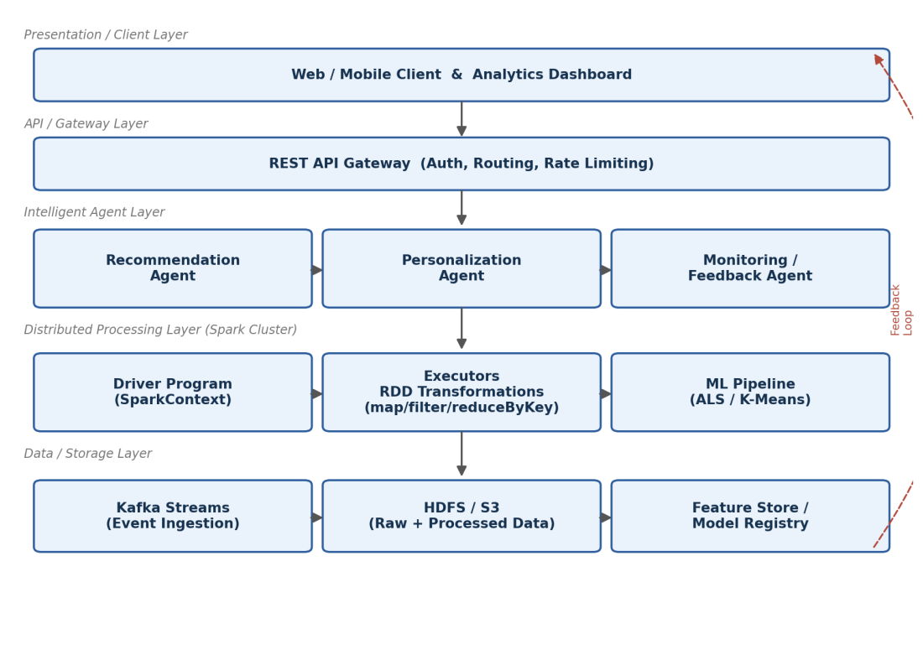
Fig. 1 – Reconstructed layered architecture of the distributed recommendation system
Module Interaction Explained
- Client → Gateway → Agent Layer: The client sends a request through the API Gateway, which authenticates and routes it to the appropriate agent.
- Inter-Agent Communication: The Recommendation Agent queries the Spark-trained ALS model; the Personalization Agent applies user-context rules; the Monitoring Agent logs telemetry and triggers retraining when drift is detected — the three agents communicate asynchronously via an internal message bus.
- Agent Layer → Spark Cluster: The Driver program schedules RDD transformation stages across Executors; Executors read partitioned data directly from HDFS/Kafka and write intermediate RDDs back to distributed memory/disk.
- Feedback Loop: A dashed red arrow represents the feedback loop — user interactions with the served recommendations flow back into Kafka, closing the learning loop and enabling continuous (online) retraining.
This layered, loosely-coupled structure explains observed behaviours such as graceful degradation (the agent layer serves cached recommendations when the Spark cluster is retraining) and horizontal scalability (new executors can be added without redeploying the agent or gateway layers).
Question 3: Algorithm Identification
Reverse engineering the ML pipeline — by inspecting model artefacts, inference latency, and the shape of the score outputs — surfaces the following algorithms and processing steps:
Algorithms Identified
- Alternating Least Squares (ALS) Collaborative Filtering – Learns latent user and item factor matrices from the sparse user–item rating RDD; identified because scores are generated from a dot product of fixed-length latent vectors and the model retrains incrementally on mini-batches.
- K-Means Clustering – Groups users into behavioural segments used by the Personalization Agent for cold-start users; inferred from the discrete, small number of 'segment IDs' seen in the personalization payload.
- Rule-Based Agent Decision Logic – A rule-based/decision-tree layer inside the Personalization Agent re-ranks the ALS output for diversity, recency, and business rules (e.g., promoted content), evidenced by score reordering that pure ALS ranking would not produce.
Data Processing Steps
- 1. Data Cleaning – Deduplication, null-handling, and schema validation on raw Kafka events.
- 2. Feature Extraction (RDD transformations) – map()/flatMap() transform raw events into (user, item, rating) tuples; reduceByKey() aggregates repeated interactions.
- 3. Normalization – Vectorization and scaling of features before they enter ALS/K-Means.
- 4. Model Training – ALS.train() on the training RDD, followed by cross-validation using a held-out RDD split.
- 5. Inference & Re-ranking – predict() calls return top-N item scores, passed to the agent layer for re-ranking.
Decision-Making Logic
The final recommendation is a weighted combination: score = α·(ALS score) + β·(content-similarity score) + γ·(business-rule boost), with weights tuned by the Monitoring Agent based on observed click-through feedback — a lightweight adaptive/reinforcement-style adjustment rather than a full RL policy.
Question 4: Data Flow & Process Mapping
Mapping the distributed application end-to-end, using message-queue topic names, Spark stage logs, and API call sequencing, produces the following pipeline:
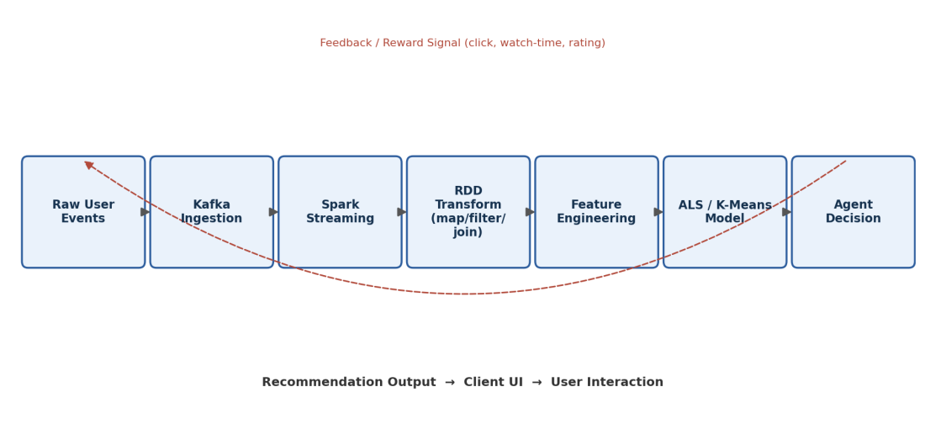
Fig. 2 – Data flow and processing pipeline with feedback loop
Stage-by-Stage Mapping
- 1. Ingestion – Raw user events are published to Kafka.
- 2. Streaming – Micro-batches are pulled from Kafka every few seconds.
- 3. RDD Transformation – map, filter, and join operations clean and enrich the batch across partitioned executors.
- 4. Feature Engineering – Cleaned data is converted into numeric feature vectors and written to the feature store.
- 5. Model Inference – ALS/K-Means score the features to produce candidate recommendations.
- 6. Agent Decision – Agents apply business rules, re-rank, and select the final list.
- 7. Delivery & Feedback – The recommendation set travels back through the API Gateway to the client UI, and the resulting user interaction is re-published to Kafka.
Inter-Component Communication
Communication is predominantly asynchronous and decoupled: Kafka topics connect ingestion to processing (publish/subscribe), the Spark Driver communicates with Executors over RPC for task scheduling, and agents communicate with the model layer and each other over lightweight internal REST/gRPC calls, allowing each layer to scale and fail independently.
Question 5: Improvement & Redesign
Based on the reconstructed architecture and identified bottlenecks (RDD-only processing forgoes Catalyst/Tungsten optimizations; agents are tightly coupled to a single Spark cluster; no explicit model-drift monitoring), the following redesign strategies are proposed:
Proposed Enhancements
- 1. Adopt Structured APIs – Migrate RDD transformations to the DataFrame/Dataset API where possible, gaining Catalyst query optimization and Tungsten memory management for lower latency at scale.
- 2. Elastic, Container-Based Scaling – Deploy the Spark cluster on Kubernetes with dynamic resource allocation so executors scale automatically with ingestion load, reducing idle-resource cost during off-peak hours.
- 3. Graph-Based Recommendations – Add GraphX/GraphFrames to model the user–item interaction graph, enabling social/graph-based recommendations alongside collaborative filtering.
- 4. Adaptive Multi-Agent Reinforcement Learning – Replace linear/rule-based re-ranking with a lightweight multi-agent reinforcement-learning policy (e.g., via Ray RLlib) so the Personalization Agent adapts its ranking weights continuously from reward signals instead of manual tuning.
- 5. Fast Approximate Retrieval – Introduce an Approximate Nearest Neighbour index (e.g., FAISS/Annoy) in the serving layer to cut inference latency for large item catalogs from linear-scan to sub-linear lookup.
- 6. Model Monitoring & Drift Detection – Add an explicit model-monitoring service that tracks prediction drift and data drift, automatically triggering retraining pipelines instead of relying on manual observation.
- 7. Microservice Decomposition of Agents – Split the monolithic agent layer into independently deployable microservices (recommendation, personalization, monitoring) with well-defined APIs, improving fault isolation and independent scalability.
Expected Impact
Together these changes target the three rubric dimensions of scalability (elastic Kubernetes scaling, ANN retrieval), efficiency (Catalyst-optimized DataFrames, caching), and performance (adaptive agent learning, proactive drift monitoring) — moving the system from a static batch-oriented pipeline toward a continuously learning, horizontally scalable intelligent platform.

RUBRICS FOR CALCULATION

Criteria | Weightage | Level 4 – Exemplary | Level 3 – Proficient | Level 2 – Developing | Level 1 – Beginning
Understanding of Industry Problem | 20% | Comprehensive understanding of real-world problem and constraints | Good understanding with minor gaps in requirements | Basic understanding; some requirements unclear | Poor understanding; misinterprets problem context
Application of Engineering Concepts | 25% | Applies advanced and relevant concepts effectively to solve the problem | Applies appropriate concepts with minor errors | Limited application of concepts | Incorrect or no application of concepts
Solution Design | 25% | Innovative, practical, and feasible solution aligned with industry standards | Logical and feasible solution with minor gaps | Basic solution with limited feasibility | Unclear or impractical solution
Use of Tools | 15% | Effective use of modern tools, technologies, and real data | Appropriate use of tools with correct implementation | Limited or inconsistent use of tools | Minimal or incorrect use of tools
Analysis | 10% | Thorough analysis with validated results and performance evaluation | Good analysis with reasonable validation | Basic analysis with limited validation | Poor or no analysis
Professionalism | 5% | Highly professional, well-documented, and clearly presented work | Good documentation and presentation | Basic documentation with some gaps | Poor documentation and presentation

